

**CS352 – Software Engineering II**

**Phase 1**

**2015**

**Project Team**

|  |  |  |  |
| --- | --- | --- | --- |
| **ID** | **Name** | **Email** | **Mobile** |
| 20120183 | Reham Sami Taie | reham.taie@hotmail.com | 01110132743 |
| 20120180 | Romisaa Attia Hussien | roma.attia@gmail.com | 01122797031 |
| 20120190 | Sara Fouad | sarafouad_111@hotmail.com | 01149026534 |
| 20120449 | Hend Mostafa | [Hendmostafa285@gmail.com](mailto:Hendmostafa285@gmail.com) | 01115015495 |

**Staff: Dr Mohammad El-Ramly m.elramly@fci-cu.edu.eg**

**TAs: Eng Mohamed Samir m.samir@fci-cu.edu.eg**

# 

# Your Restful API

**MessageService**

|  |  |
| --- | --- |
| **Service name** | **MessageService** |
| **Input type** | **POST** |
| **Service URL** | **http://fci-swe-apps.appspot.com/rest/messageService** |
| **Parameters** | |  |  | | --- | --- | | **NAME** | **Description** | | **Sender** | **Provided user name** | | **receiver** | **Provided the user name that received message** | | **message** | **Message provided message content** | |
| **Example request** | **POST**  **http://** **fci-swe-apps.appspot.com /rest/messageService?Sender=** **aaa&receiver=bbb&message="ccc".** |
| **Example response** | **{"message":"ok" , "Sender":Active username"}**  **Send message to other user.** |

**conversationService**

|  |  |
| --- | --- |
| **Service name** | **conversationService** |
| **Input type** | **POST** |
| **Service URL** | **http://fci-swe-apps.appspot.com/rest/conversationService** |
| **Parameters** | |  |  | | --- | --- | | **NAME** | **Description** | | **Name** | **Provided user name** | | **ID** | **Provided the conversationID** | |
| **Example request** | **POST**  **http://** **fci-swe-apps.appspot.com /rest/conversationService?ID=** **1&Name=aaa.** |
| **Example response** | **{"status":"success" }**  **Take member name and conversation id and save them in conversation table.**  **Write {conversationID=1 , MemberName=aaa}.** |

**msgcheckService**

|  |  |
| --- | --- |
| **Service name** | **msgcheckService** |
| **Input type** | **POST** |
| **Service URL** | **http://fci-swe-apps.appspot.com/rest/msgcheckService** |
| **Parameters** | |  |  | | --- | --- | | **NAME** | **Description** | | **ID** | **Provided conversationID** | | **Message** | **Provided the Message** | |
| **Example request** | **POST**  **http://** **fci-swe-apps.appspot.com /rest/msgcheckService?ID=** **1&Message="Hi".** |
| **Example response** | **{"status":"success" }**  **Take member name and conversation id and check if exists in conversation table,**  **if yes it save them with message in MessageContent table.**  **Write {conversationID=1 , MemberName=ActiveUser ,Message="HI"}.** |

# 

# Class diagram design

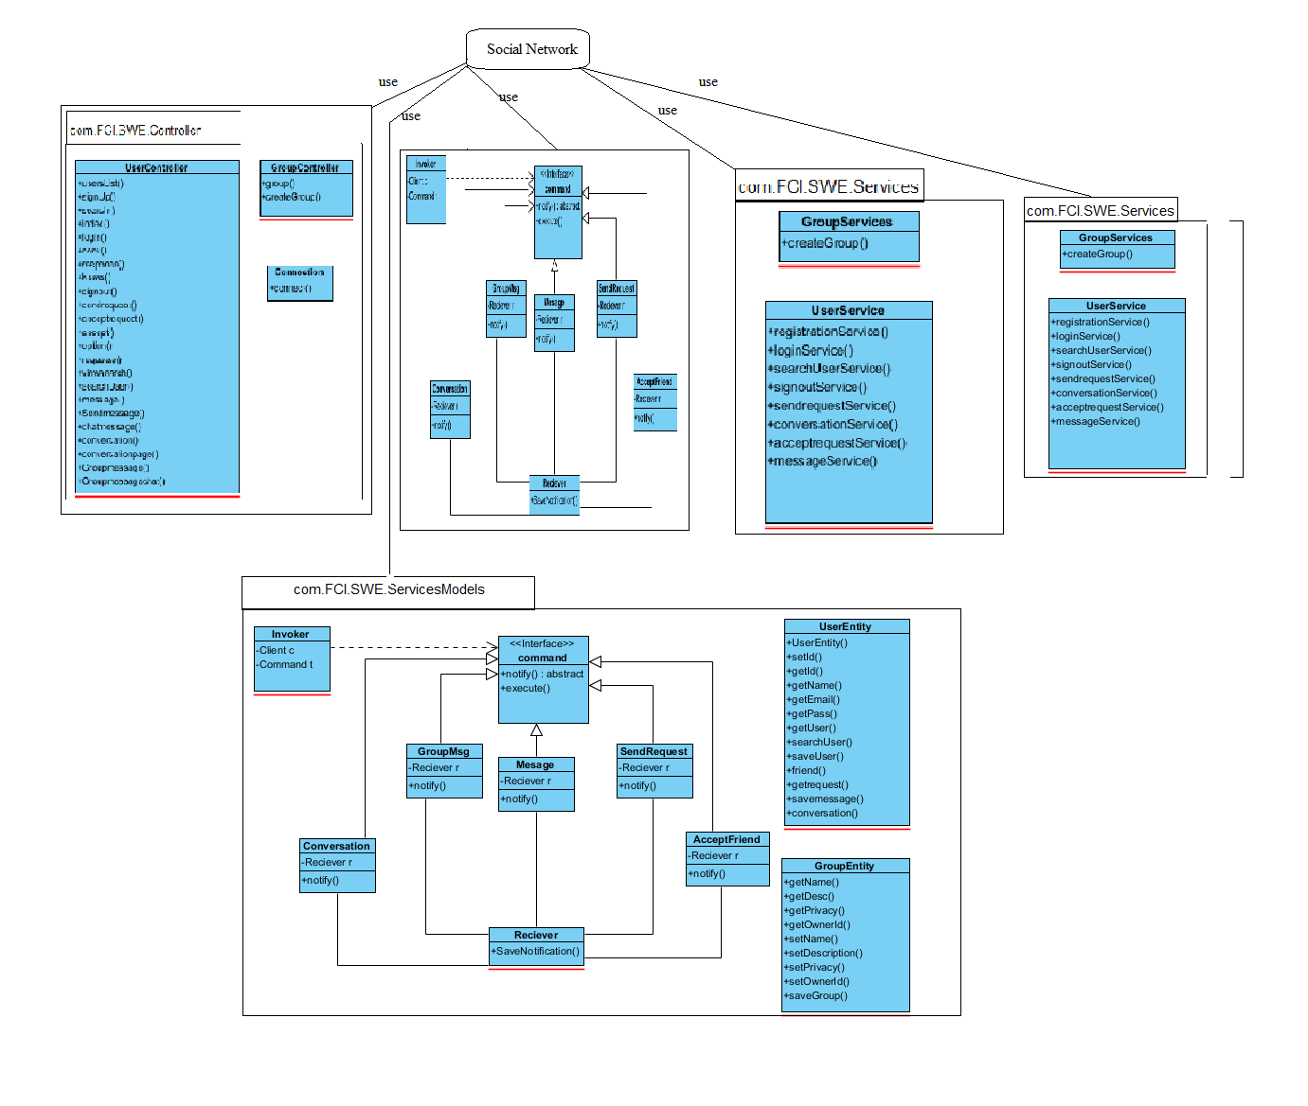

# Trello workspace screenshot

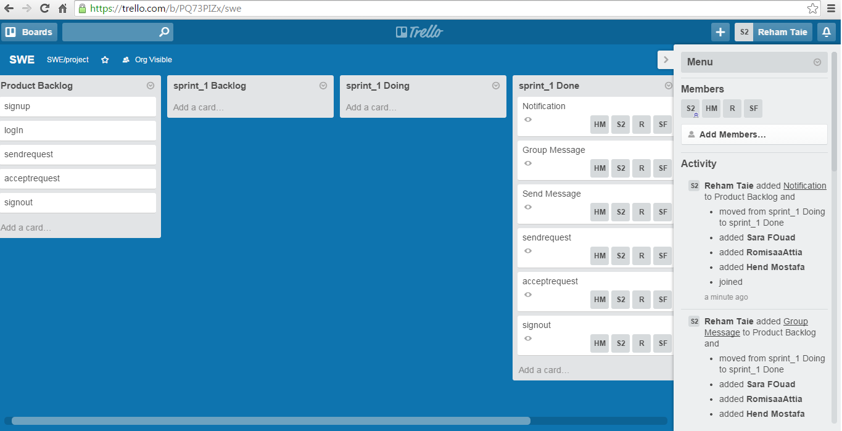

# Github repository link

**https://github.com/Reham-Taie/FCI-CS352-SWE-Team.git**